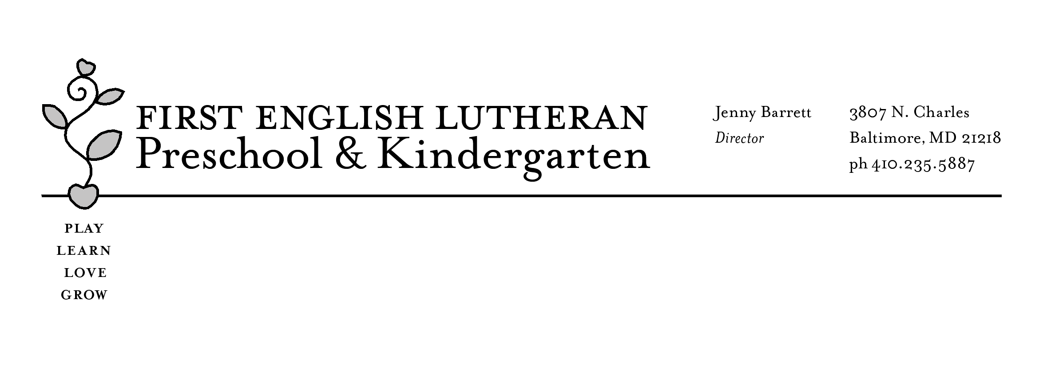
Request for Tour/Application

Child’s Name: ___________________________ Date of Birth: __________

Parent/Guardian Name(s): ________________________________________

Phone Number(s): ___________________________________ (cell/home/work)

____________________________________ (cell/home/work)

Email: _______________________________________________

Address: ______________________________________________

*Days you are available for a tour: _______________________

**Have you previously toured our school? Yes / No

How did you hear about FELP? ____________________________

*Tours are most informative at 9:30 in the morning. Ideally, we would schedule the tour when the prospective fall class is in session. Typically at the tour, you are provided with an application.

**If you have previously toured the school or have had a child at our school, please contact us and we can send you the application directly.

The completed application, along with a $60 fee, puts your name on our prospective student list. Contracts are sent to families beginning in January or February for the next year using the names on that list. Some classes have spaces through summer while others have a waitlist.

Our contact information: felpkids@gmail.com/410-235-5887

